Załącznik 1 – WIZERUNEK MARYJI – PUZZLE

[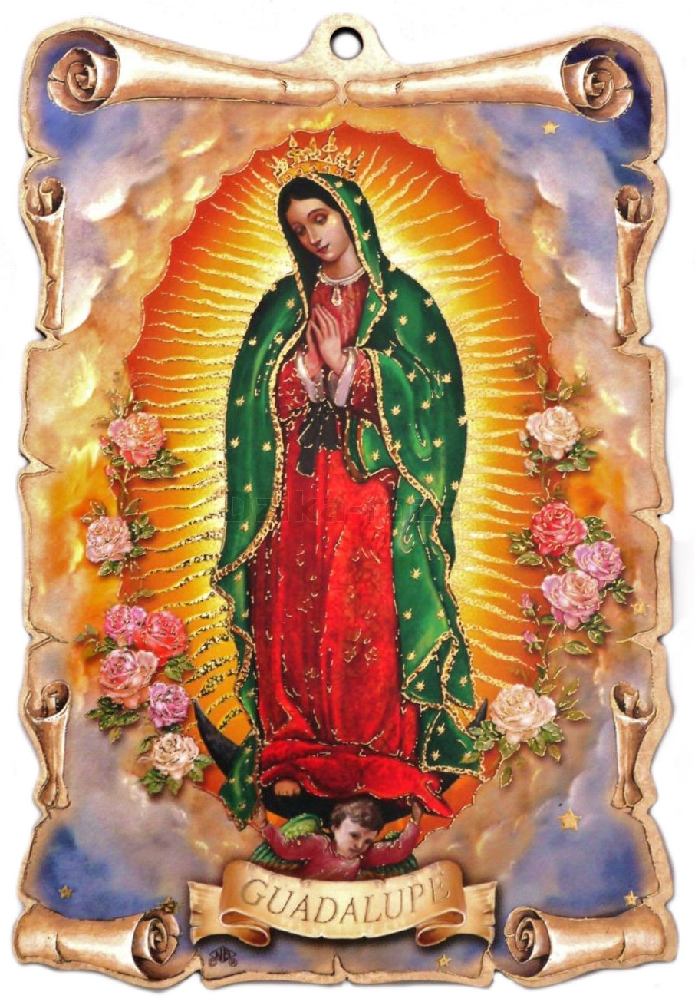](https://www.google.pl/url?sa=i&rct=j&q=&esrc=s&source=images&cd=&cad=rja&uact=8&ved=0ahUKEwi8kNT6_-3ZAhVmP5oKHTmbClcQjRwIBg&url=http://dewocjonalia-roza.pl/matka-boska-z-guadalupe-p-1012.html&psig=AOvVaw3yBbceREOUJUh81P4LYYp3&ust=1521192001304030) [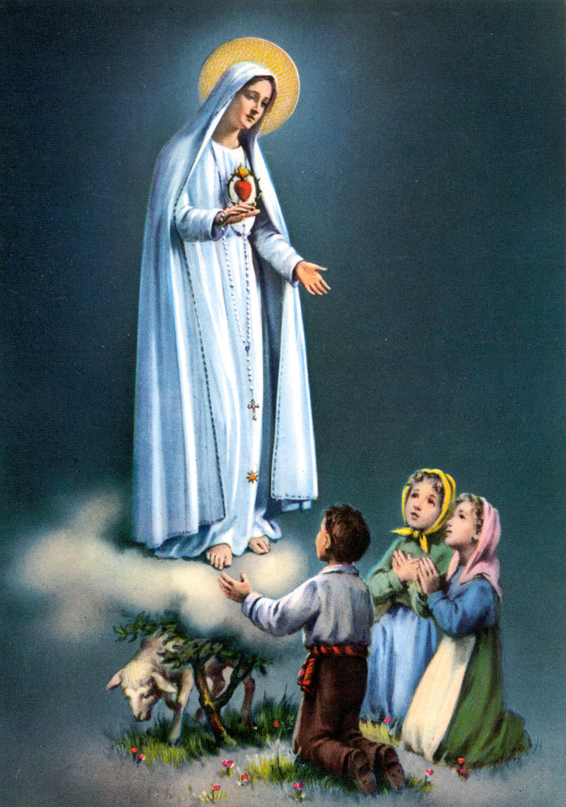](https://www.google.pl/url?sa=i&rct=j&q=&esrc=s&source=images&cd=&cad=rja&uact=8&ved=0ahUKEwjGwtmlgO7ZAhXiApoKHSSyAKQQjRwIBg&url=http://obrazmojegoserca2.blog.onet.pl/2013/10/13/13-10-1917r-matka-boska-fatimska/&psig=AOvVaw1kOYDVounaP_HhFH_o4vQR&ust=1521192086025698)

[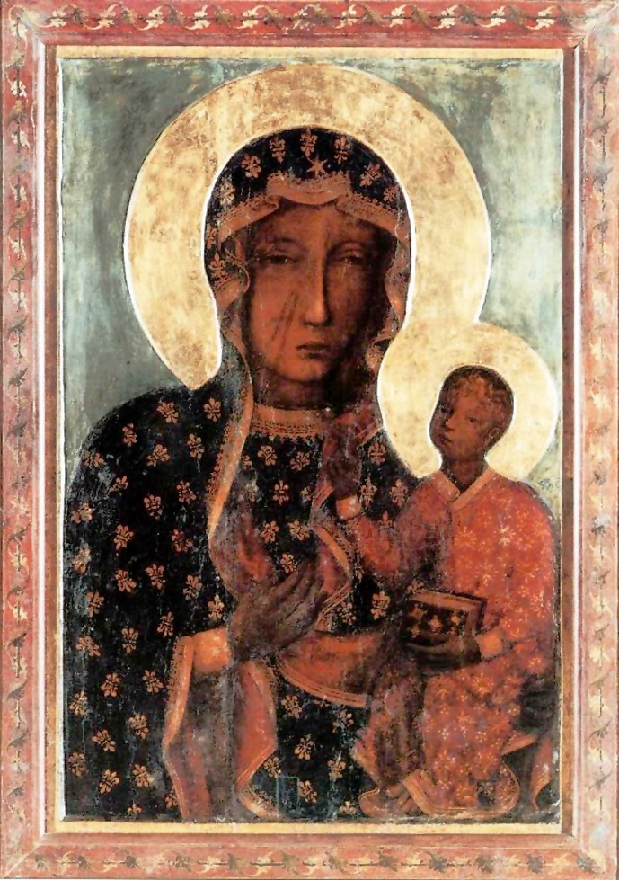](https://www.google.pl/url?sa=i&rct=j&q=&esrc=s&source=images&cd=&cad=rja&uact=8&ved=0ahUKEwj1jazHgO7ZAhXCE5oKHQG0BRgQjRwIBg&url=https://pl.wikipedia.org/wiki/Obraz_Matki_Boskiej_Cz%C4%99stochowskiej&psig=AOvVaw1xvs127yhsOY9R7he18R3e&ust=1521192160043925) [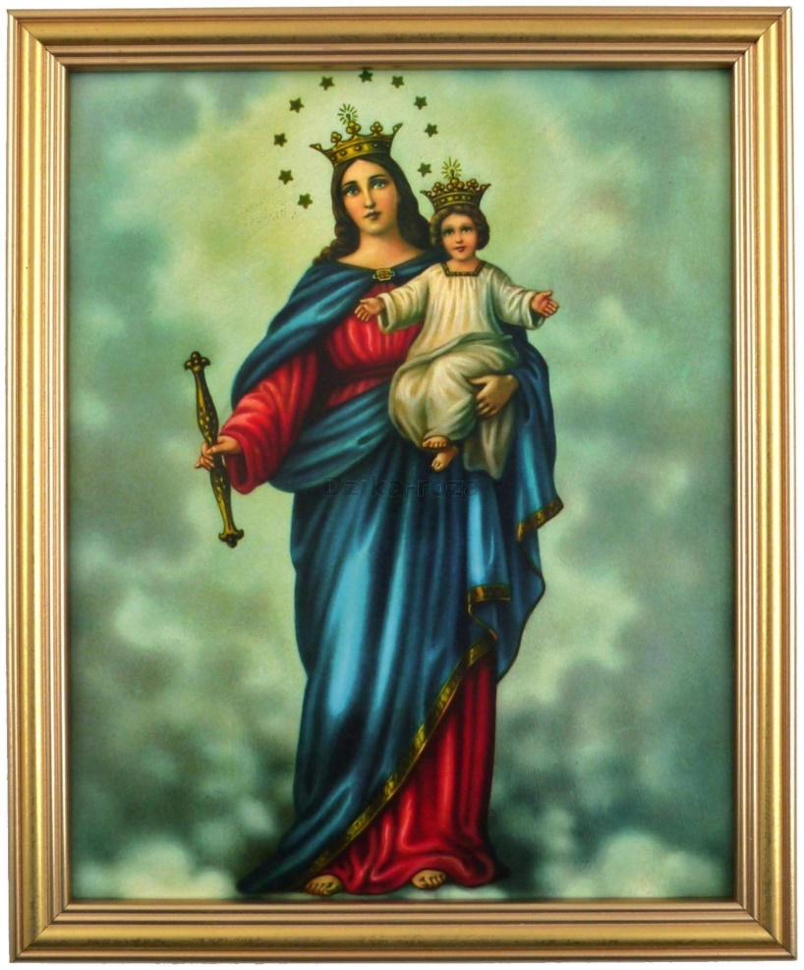](https://www.google.pl/url?sa=i&rct=j&q=&esrc=s&source=images&cd=&cad=rja&uact=8&ved=0ahUKEwjWu4iAge7ZAhUHQJoKHTzvB6sQjRwIBg&url=http://dewocjonalia-roza.pl/matka-boza-wspomozycielka-wiernych-p-2627.html&psig=AOvVaw0SwGSYKONsvKHUr1W1Qm_4&ust=1521192259735438)

[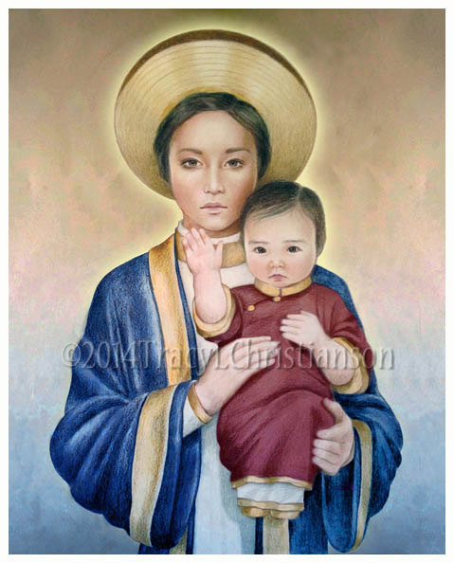](https://www.google.pl/url?sa=i&rct=j&q=&esrc=s&source=images&cd=&cad=rja&uact=8&ved=0ahUKEwjHquC1ge7ZAhXHApoKHe-CA4cQjRwIBg&url=https://www.etsy.com/mx/listing/110025288/nuestra-senora-de-lavang-arte-imprime-el&psig=AOvVaw2l7hkwaqSO_hFQ9c7Y5WkZ&ust=1521192343610156)[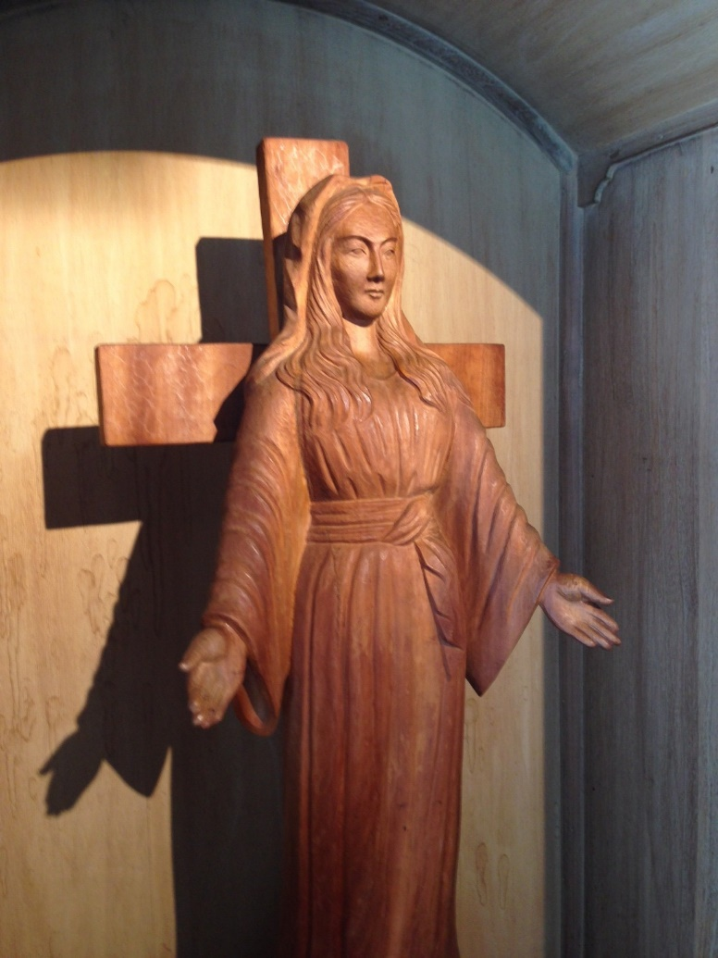](https://www.google.pl/url?sa=i&rct=j&q=&esrc=s&source=images&cd=&cad=rja&uact=8&ved=0ahUKEwjIr_3zg-7ZAhVpDZoKHR8SDFUQjRwIBg&url=http://naszdomjp.exblog.jp/tags/Matka%20Boska%20z%20Akita/&psig=AOvVaw1R73Z3ZE3CpTQZ8mAr7oJ3&ust=1521192978393519)

MINIATURY OBRAZÓW DO MAPY ŚWIATA

[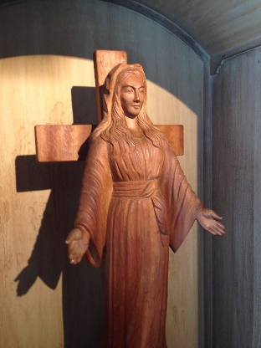](https://www.google.pl/url?sa=i&rct=j&q=&esrc=s&source=images&cd=&cad=rja&uact=8&ved=0ahUKEwjIr_3zg-7ZAhVpDZoKHR8SDFUQjRwIBg&url=http://naszdomjp.exblog.jp/tags/Matka%20Boska%20z%20Akita/&psig=AOvVaw1R73Z3ZE3CpTQZ8mAr7oJ3&ust=1521192978393519) [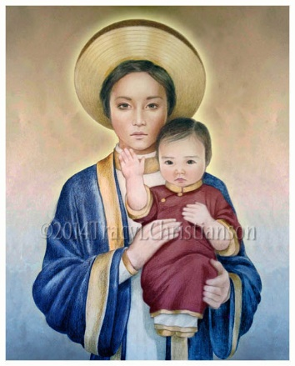](https://www.google.pl/url?sa=i&rct=j&q=&esrc=s&source=images&cd=&cad=rja&uact=8&ved=0ahUKEwjHquC1ge7ZAhXHApoKHe-CA4cQjRwIBg&url=https://www.etsy.com/mx/listing/110025288/nuestra-senora-de-lavang-arte-imprime-el&psig=AOvVaw2l7hkwaqSO_hFQ9c7Y5WkZ&ust=1521192343610156) [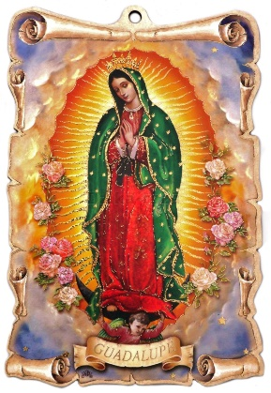](https://www.google.pl/url?sa=i&rct=j&q=&esrc=s&source=images&cd=&cad=rja&uact=8&ved=0ahUKEwi8kNT6_-3ZAhVmP5oKHTmbClcQjRwIBg&url=http://dewocjonalia-roza.pl/matka-boska-z-guadalupe-p-1012.html&psig=AOvVaw3yBbceREOUJUh81P4LYYp3&ust=1521192001304030) [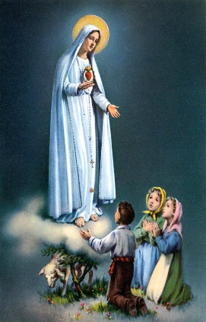](https://www.google.pl/url?sa=i&rct=j&q=&esrc=s&source=images&cd=&cad=rja&uact=8&ved=0ahUKEwjGwtmlgO7ZAhXiApoKHSSyAKQQjRwIBg&url=http://obrazmojegoserca2.blog.onet.pl/2013/10/13/13-10-1917r-matka-boska-fatimska/&psig=AOvVaw1kOYDVounaP_HhFH_o4vQR&ust=1521192086025698)[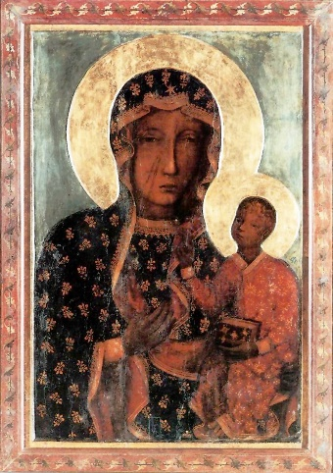](https://www.google.pl/url?sa=i&rct=j&q=&esrc=s&source=images&cd=&cad=rja&uact=8&ved=0ahUKEwj1jazHgO7ZAhXCE5oKHQG0BRgQjRwIBg&url=https://pl.wikipedia.org/wiki/Obraz_Matki_Boskiej_Cz%C4%99stochowskiej&psig=AOvVaw1xvs127yhsOY9R7he18R3e&ust=1521192160043925)[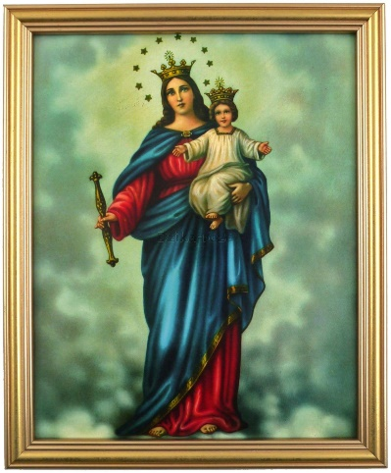](https://www.google.pl/url?sa=i&rct=j&q=&esrc=s&source=images&cd=&cad=rja&uact=8&ved=0ahUKEwjWu4iAge7ZAhUHQJoKHTzvB6sQjRwIBg&url=http://dewocjonalia-roza.pl/matka-boza-wspomozycielka-wiernych-p-2627.html&psig=AOvVaw0SwGSYKONsvKHUr1W1Qm_4&ust=1521192259735438)